**Guvi Day 19 Task**

**API Endpoints**

**Home Controller:**

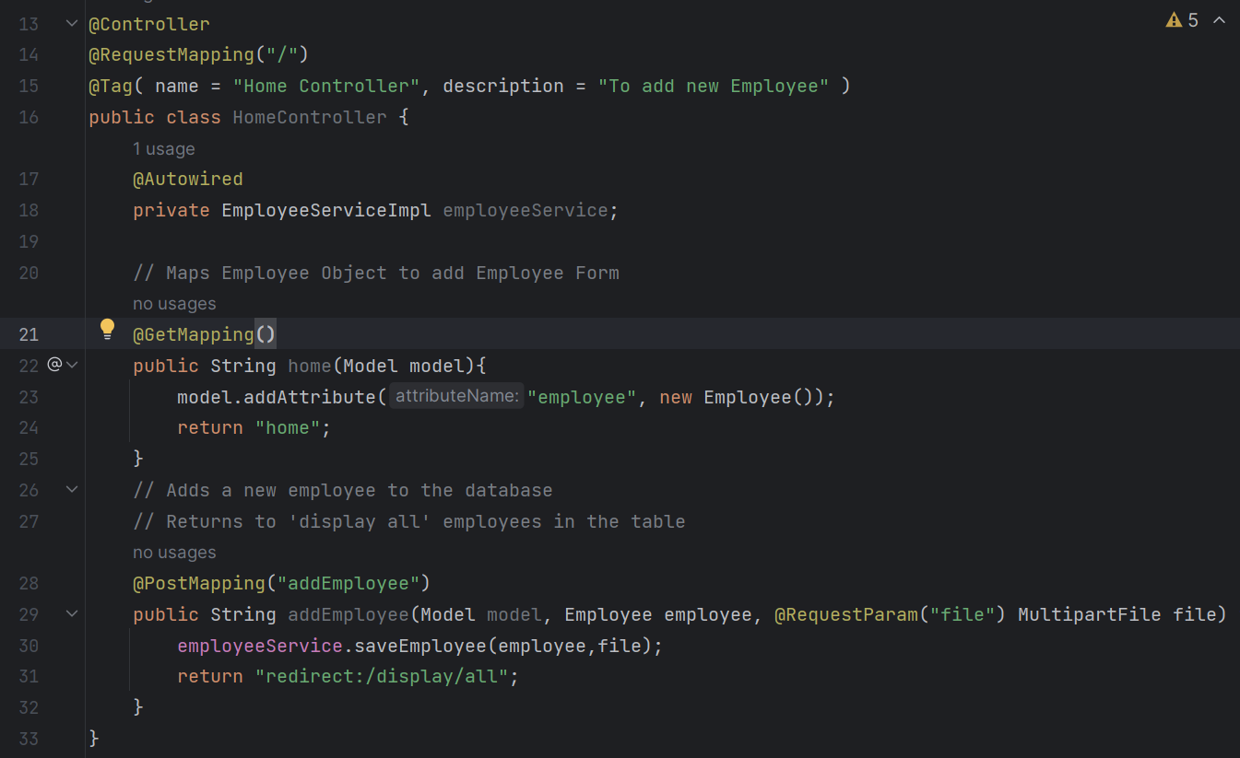

**Endpoints:**

* **Localhost:8080/ -** returns Add New employee form
* **Localhost:8080/addEmployee –** Save &returns to display/all page

**Display All Controller**

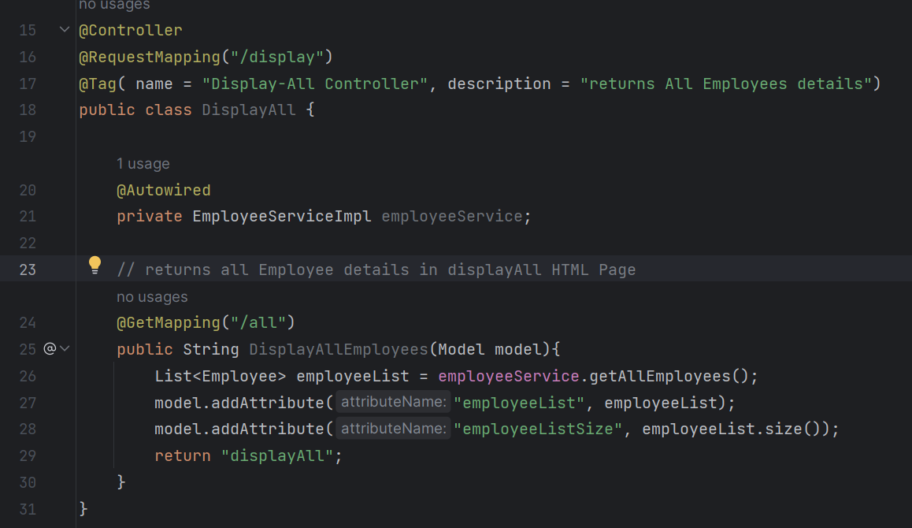

**Endpoints:**

* **Localhost:8080/display/all -** returns all Employees details in displayAll HTML Page

**Display-by-Id Controller**

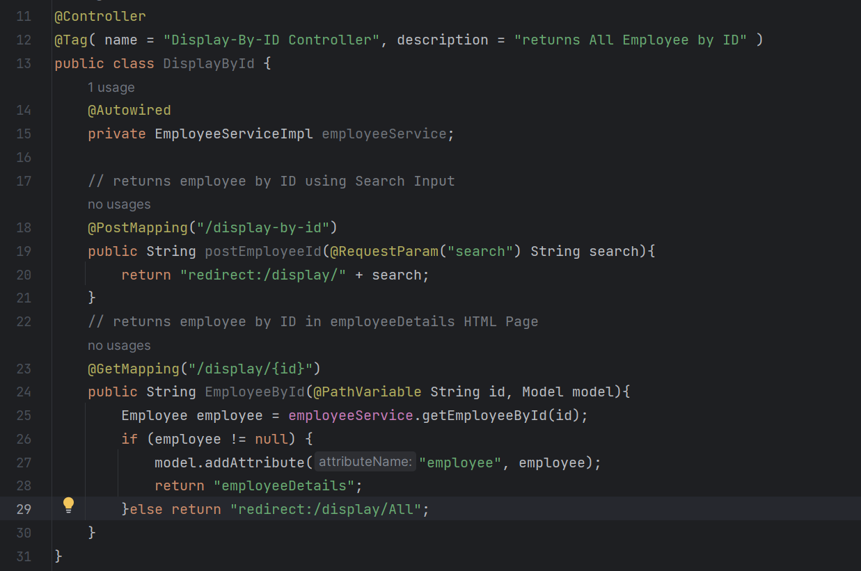

**Endpoints:**

* **Localhost:8080/display/{id} -** returns Employee by ID in EmmployeeDetails HTML Page.